Assignment 2 :

- Design and Simulate 8:3 Encoder. Simulate all possible input combinations and verify the output.
Verilog code :
module encoder_8_to_3 (
input [7:0] in,
output reg [2:0] out
);
always @(*) begin
case (in)
8'b00000001: out = 3'b000;
8'b00000010: out = 3'b001;
8'b00000100: out = 3'b010;
8'b00001000: out = 3'b011;
8'b00010000: out = 3'b100;
8'b00100000: out = 3'b101;
8'b01000000: out = 3'b110;
8'b10000000: out = 3'b111;
default: out = 3'b000;
endcase
end
endmodule

Compilation of the codes :
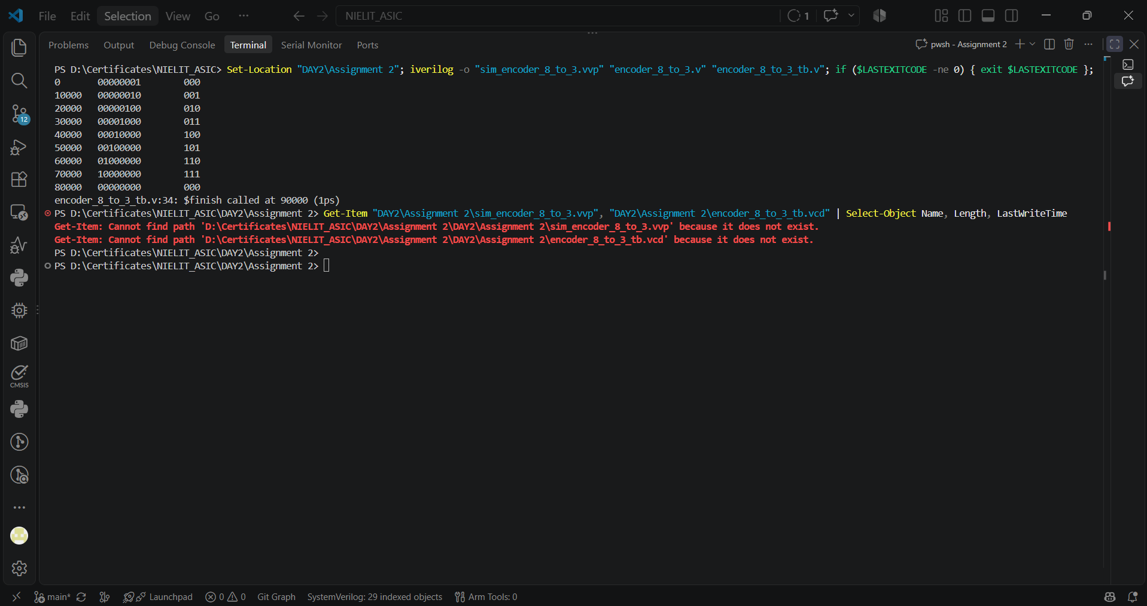

Simulation Waveforms :
The Input values shown are in the Hexadecimal. The output selection is based on the inputs and stuff.
